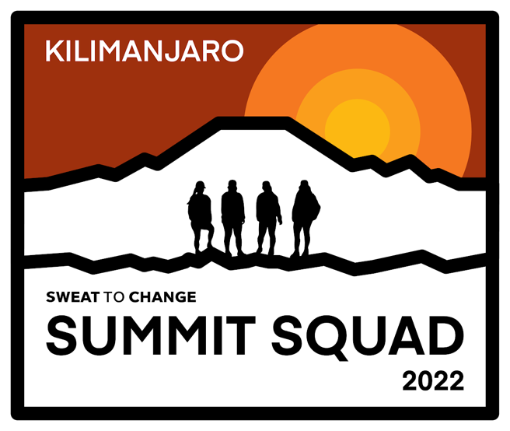
SPONSORSHIP
OPPORTUNITIES
AUG 10-17th, 2022 EXPEDITION
MOUNT KILIMANJARO, AFRICA
